|  |
| --- |
| Circle Language Spec: Execution Control |

## Label & Goto in a Diagram

The concept of labels and goto is covered by the article *Label & Goto*. The current article only explains its expression in a diagram.

Here is an example of a call to a Goto command:

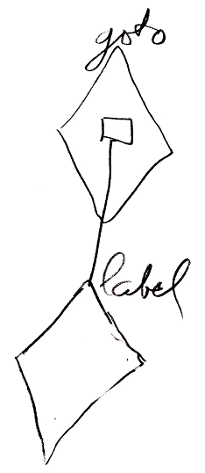

The public contents of the definition of the Goto command look like this:

